**ACTIVITY**

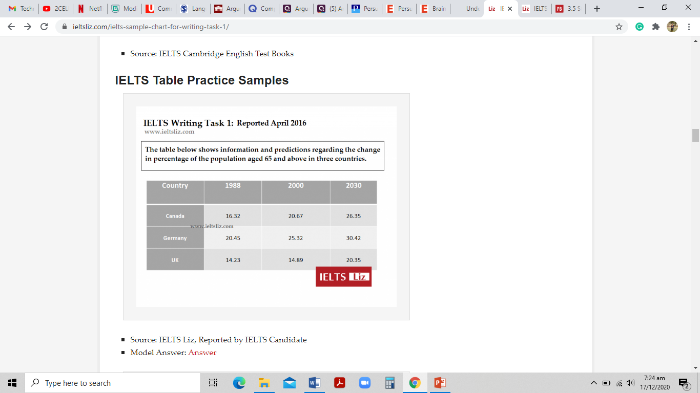

**Tips:**

1. Identify the trends
2. Take notes for the years, countries mentioned
3. Focus on the percentages
4. Choose words (according to the increase, decrease in the pattern)
5. Divide your paragraph after logical sequencing

**Write a short report on the given image. (Word count: 250-300)**

|  |
| --- |
| The table illustrates the change in percentage of the people aged 65 and above in Canada, Germany, and the Uk from 1988 to 2030. Overall, it can be seen that the percentages have been increasing over the years for each country, but Germany has the maximum percentage at the end of each decade.  In 1998 Canada, Germany and Uk have 16.32, 20.45, and 14.23 percent respectively of the population having age 65 or above. While Germany still had the maximum percentage at that time too. From 1998 to 2000 both the percentages of Canada and Germany have gradually increased however there is a very slight increase in the values of the UK.  Over the next decades from 2000 to 2030, the same pattern is being followed. There has been a dramatic increment in the percentage of Canada. Germany has almost constant change but this time the UK has an enormous increase in the percentage, as compared to previous years, from 14.89 to 20.35. The maximum percentage goes up to 30.42 for Germany.  It can be concluded that the percentage of the population aged 65 and above has been increasing since the year 1988 for each country, and it will be increasing further in upcoming years too. It can now be predicted that the UK will have a massive rise in the percentage following the pattern. |
|  |